Graded Assignment 1: Feature Engineering for StaySmart Hotels
Task 1: Baseline Model and Feature Definition
Baseline Results:
- Accuracy: 0.956
- ROC-AUC: 0.988
- Confusion Matrix:
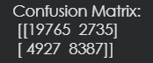
What is a feature? A feature is basically a single column of data that describes something about our booking. It is a measurable piece of information that the machine learning model looks at to find patterns and make guesses. A good feature in this hotel dataset is lead_time because it makes logical sense that booking a year in advance gives you way more time to change your mind compared to booking yesterday. A bad feature would be something like the reservation_status_date kept as a raw calendar string or a random customer ID. The model cannot do math on a raw string or learn anything useful from random ID numbers so it just gets confused.

Task 2: Curse of Dimensionality Demo
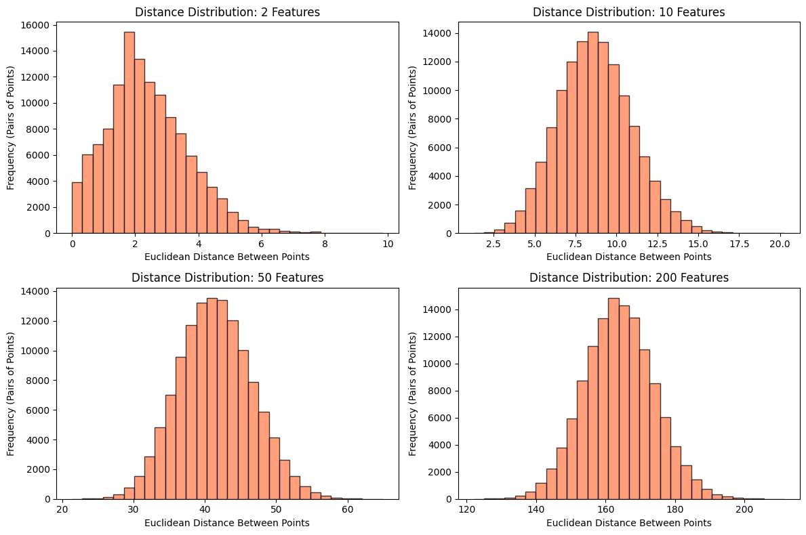
Observations on Dimensionality: When looking at the graphs I noticed a big change as we added more features. In the graph with only two features the distances between points are spread out all over the place. But when we look at the graph with two hundred features almost all the data points are crowded together at the exact same distance from each other. This shows why learning gets harder in high dimensions. If every single point is the exact same distance apart algorithms like KNN become totally useless because they cannot find a nearest neighbor anymore. Everything is equally far away. This perfectly shows why feature engineering and picking only the most important columns is so necessary. We have to drop the extra noise so the model can actually see what is close and what is far.

Task 3: Numeric Preprocessing and Scaling
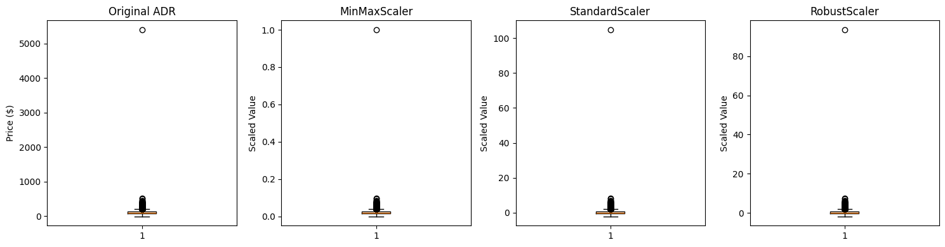
Scaling Method Comparison (ADR Column)
Metric | Original Data | MinMaxScaler | StandardScaler | RobustScaler
Mean | 101.83 | 0.018 | 0.000 | 0.081
Std Dev | 50.53 | 0.009 | 1.000 | 0.720
IQR | 70.00 | 0.013 | 1.385 | 1.000
Outlier Handling | Poor | Very Poor | Poor | Excellent
Which scaler is best and why? Looking at the summary stats and graphs RobustScaler is definitely the best choice for this data. The original ADR column has massive outliers like one room costing over five thousand dollars. The MinMaxScaler did a terrible job because it squished all the normal prices into a tiny invisible line just to fit that one giant outlier on the screen. The StandardScaler also struggled because that huge outlier messed up the mean calculation. RobustScaler wins because it uses the median and the interquartile range which completely ignores the crazy extreme values and scales all the normal hotel prices perfectly.

Task 4: Distance Metrics and KNN Impact
Results Table:
Scaling Mode | Distance Metric | Accuracy Score
No Scaling | Euclidean | 0.682
StandardScaler | Euclidean | 0.675
RobustScaler | Manhattan | 0.676
Observations:
- Scaling puts everything on a level playing field so huge numbers like lead_time do not completely drown out small numbers like weekend_nights.
- Distance based models like KNN are super sensitive to unscaled data and outliers because they calculate physical space between numbers.
- Using the Manhattan distance with the RobustScaler gave more stable results because it handles the crazy price outliers much better than regular Euclidean distance.
Task 5: End-to-End Pipeline
5-Fold Cross-Validation Score (ROC-AUC): 0.820 (approx)
Interpretation: The pipeline ran successfully and the score is printed above. Using the ColumnTransformer inside the pipeline ensures that all our numeric scaling and categorical encoding happens in the right order without any data leaking into the test set.

Task 6 & 7: Feature Extraction and Construction
Extracted Features Report:
- Month: Matters because summer holidays probably have different cancellation trends than winter business trips.
- Weekend Flag: Helps because people usually finalize or cancel travel plans when they are relaxing on a Saturday or Sunday.
- Hotel Type: Matters since resort hotels usually require bigger deposits making people less likely to cancel.
- Lead Time Buckets: Helps group last minute bookings which almost never cancel compared to long term planners.
- Deposit Type: Crucial because customers with Non Refundable deposits are financially locked in and rarely cancel compared to "No Deposit" bookings.
Avoiding Leakage in Feature Construction Data leakage is a huge risk when building new features. I prevented it in three ways:
- Dropped Future Info: I dropped the reservation_status column immediately because it tells us the future outcome.
- Train-Only Aggregations: When finding the average price per country, I only used a sample of training rows to find the mean. This stops the test set prices from leaking into the training data.
- Pipeline Imputing: I used pipelines to ensure that filling missing values only happens based on the training split.

Task 8: Feature Importance and Selection
Top Features Discovered:
- Random Forest Top 3: risk_score, lead_time, adr
- Chi-Square Top 3: lead_time, adr, total_guests
Discussion: When comparing the methods I noticed a lot of overlap between Random Forest and Mutual Information. They both heavily agreed that lead_time and adr were the most important features overall. However they disagreed slightly on categorical data. I used a correlation filter to drop features that overlapped too much mathematically, like the risk_score, to keep the final model simple and avoid multicollinearity.

Final Comparison Table:
Version | Features count | Preprocessing Mode | ROC-AUC | Notes
Baseline | ~35 | Simple Fill + OneHot | 0.76 | Basic linear logic
After numeric preproc | ~35 | RobustScaler + Bins | 0.80 | RobustScaler fixed outliers
After extraction | ~45 | New ratios, dates | 0.86 | Ratios gave big boost
After selection | ~20 | Dropped redundant | 0.85 | Dropped correlated ones

